

Author:
Ivan Damnjanović
Founder & CEO
Ambient Systems

Date: April 28th, 2024

Executive Summary

Revolutionizing Financial Management with AI-Powered Simplicity for Key Industries

Businesses of all sizes struggle with complex and expensive financial management solutions like ERPs. These systems often lack user-friendliness, hindering efficient workflows and limiting access for smaller companies.

Ambient Systems offers a revolutionary AI-powered financial management platform designed for simplicity and depth of insights. The company focus is on empowering mid-sized to large companies in critical industries like:
- Transportation & Logistics: Streamline financial operations, optimize fuel costs, and gain real-time insights for informed decision-making.
- Commercial Real Estate: Enhance property portfolio management, improve energy efficiency, and automate financial reporting.
- Vertical Farming: Optimize resource allocation, monitor crop health, and gain data-driven insights for informed decision-making.
- Construction: Improve project budgeting and forecasting, streamline financial workflows, and enhance risk management.

Our Value Proposition:
- Effortless Data Integration: We seamlessly integrate data from diverse sources (ERP, IoT sensors, financial records) into a unified platform, eliminating manual tasks and ensuring data accuracy.
- AI-Powered Analytics: Gain valuable insights from real-time data to optimize financial performance, resource allocation, and forecasting.
- Intuitive User Experience: Our user-friendly interface promotes independent work and streamlines financial processes, empowering a broad spectrum of professionals – from FP&A teams and CFOs to data scientists and executives.
- Cost-Effective Alternative: Ambient Systems provides robust functionalities at a fraction of the cost of traditional ERPs, making it an accessible solution for SMEs.

Competitive Advantage:
- Deep Tech Differentiation with AI: Leveraging cutting-edge AI, we automate tasks, predict trends, and generate insightful reports, empowering businesses to make data-driven decisions and achieve a significant competitive edge.

Investment Opportunity:
Ambient Systems presents a compelling investment opportunity for venture capitalists seeking to disrupt the financial management landscape. We offer a unique combination of user-friendliness and AI-powered functionalities, positioning the company for rapid growth in key industry segments.

Section 1: Products & Solutions to Be Developed

Concept, Features, and Application
Ambient Systems is building a cloud-based software for financial insights and planning. At its core, the platform acts as a unified data hub, bringing together financial information, operational data, and sensor readings from connected devices. By seamlessly integrating internet-of-things (IOT) data such as sensors and enterprise resource planning (ERP) system insights, Ambient Systems offers a holistic approach to financial management while freeing clients from the difficulties of balancing numerous mega-tools within the organization. Ambient’s solution focuses on simplicity and effectiveness, empowering clients to optimize profitability without the complexity. With Ambient Systems, clients can achieve improved profitability while enjoying the freedom to focus on what matters most to your business.

Key Features
The company is offering two sets of products, aimed at slightly different target pain points.
 | Deep Tech Product | FinTech Product
General Features
Cloud-Based | ✓ | ✓
Cross-Platform: Mac, Linux, Windows | ✓ | ✓
Data Types Supported:  - Finance Data  - ERP Data  - Documents | ✓ | ✓
Dashboard Visualization | ✓ | ✓
PDF Reports | ✓ | ✓
AI-supported Data Integration | ✓ | ✓
AI-supported Financial Management | ✓ | ✓
Deep Tech Features
Data Types Supported:  - Internet-of-Things (IoT)  - Images & Videos | ✓ | X
Calculates Operational Metrics | ✓ | X
Custom AI Models | ✓ | X

Key Features:
- Cloud-Based: Accessible from anywhere with an internet connection, fostering remote work and collaboration.
- Cross-Platform Compatibility: Works seamlessly on various operating systems (Mac, Linux, Windows), increasing user flexibility.
- Data Integration: Connects effortlessly with existing ERP and IoT systems, eliminating manual data entry and ensuring data consistency.
- User-Friendly Interface: Designed for ease of use, allowing for quick adoption and efficient information retrieval.
- Dashboard Visualization: Provides customizable dashboards with interactive features for clear and insightful data presentation.
- PDF Reports: Generates in-depth reports for comprehensive data analysis and sharing.
- AI-powered Data Integration & Financial Management: Automates data handling and utilizes AI for financial analysis, streamlining workflows and improving decision-making.
Deep Tech Features:
- IoT Sensor Data Integration: Analyzes data from sensors and machines, providing operational insights beyond traditional financial data.
- Image & Video Processing: Extracts valuable information from images and videos, enriching data analysis for a more holistic understanding.
- Operational Metrics Calculation: Automates the calculation of KPIs, allowing for continuous process optimization and performance tracking.
- Custom AI Models: Enables the development of unique AI models tailored to specific business needs, further enhancing the platform's functionality.
Applications:
- Financial Planning & Analysis: Gain insights for informed financial forecasting, budgeting, and resource allocation.
- Operational Efficiency Improvement: Leverage data from sensors and machines to identify areas for process optimization and cost reduction.
- Risk Management: Proactively identify potential financial risks with AI-powered analysis.
- Improved Decision-Making: Gain data-driven insights to support strategic financial decisions.
- Enhanced Reporting & Compliance: Generate comprehensive reports for internal analysis and meet regulatory compliance requirements.
Target industries: vertical farming, commercial real estate, construction, and transportation.
The product demo can be viewed in Appendix D: Product Demo.

Section 2: Research and Development Plan (R&D)
This R&D roadmap outlines the development plan for Ambient Systems, a powerful AI-powered financial management platform. This plan integrates the three key development phases with the six-step milestone plan, providing a comprehensive view of activities and expected deliverables.
Phase 1: Business Planning Software Foundation - Aligns with Milestone 1 (Months 0-3)
This phase lays the groundwork for the cloud-based Business Planning Software.
Activities include:
- Cloud Infrastructure & Data Management:
  - Maintain existing CI/CD pipeline and cloud platform documentation.
  - Identify and document user requirements for pilot implementation
  - Configure process for AI development with a hybrid cloud infrastructure (OVH – GCP Firebase).
- Enhanced Data Integration:
  - Improve the data integration feature to display status, source, quality, and end-use of data.
  - Update automated data integration with robust validation checks.
  - Implement data governance features for user management and permission control.
- Data Management & Sample Data Collection:
  - Collect sample data from four target industries: vertical farming, commercial real estate (CRE), transportation bus fleets, and construction.
  - Import sample data and relevant financial metrics libraries into the cloud platform.
  - Explore partial migration of specific workloads between cloud providers (GCP to OVH)
- Hardware Data Configuration Prototype:
  - Demonstrate a plug-and-play data sensor that streams real-time data to the cloud-based server (AWS/GCP).
  - Configure m5stack devices to display live data sampling on the cloud server through a visualization dashboard.
Phase 2: Advanced Financial Analysis & AI Integration - Aligns with Milestones 2 & 3 (Months 4-15)
Phase 2 focuses on expanding financial analysis capabilities and integrating AI functionalities.
Activities include:
- Financial Analysis & Reporting:
  - Develop features allowing users to input historical and future key financial metrics like revenue, expenses, and cash balance.
  - Enable users to track account transactions (realized/unrealized).
- AI Smart Advisor Integration:
  - Develop and connect an AI Advisor to support users in:
    - Generating draft reports
    - Identifying relevant data points
    - Analyzing data and assisting with goal setting for financial improvement (benchmarking).
- Data Integration Prototype for the Deep Tech Product Offering:
  - Establish ETL (Extract, Transform, Load) processes to handle diverse data inputs including financial records, ERP data, images, videos, documents, and IoT sensor data.
- Pilot Implementation
  - Conduct field pilot study or studies with finance teams in construction, commercial real estate, and transportation companies in Hong Kong or GBA or SEA, demonstrating financial benefits of the comprehensive solution.
Phase 3: Future Development - Aligns with Milestones 4 to 6 (Months 16 – 33)
Following the successful completion of Phase 2, the roadmap outlines further development efforts which can be incorporated into subsequent iterations. These efforts include:
- Hardware Design Improvements
  - Hardware design improvements consisting of multimodal sensing, miniaturization, sensor fusion, and Low-Power Wide-Area Networks (LPWAN) adoption
  - Hardware improvements for on-device AI implementation, alternative displays, and energy-efficient power supply
- Internationalization
  - Internationalization of product designs to different languages and regions, including China, Japan, and Europe
- FSI Functionality Expansion
  - Expand functionality to new use cases in FSI industry vertical, such as banking, asset management, and insurance
- Custom AI Models
  - New AI models will be developed for new use cases in the industries by focusing on a deep dive that allows significant operational improvements that drive financial performance benefits to the business

Section 3: Sales and Marketing Plan

Market Segmentation:
Ambient Systems sales and marketing plan starts by focusing on go to market niche. Ambient Systems has also generated a list of customer segments and identified number of accounts and leads that it wants to pursue. These are included in Appendix F: Market Segments. The number of leads is used for estimating the total market size in terms of revenue, which is included in the financial model.

Target Market
Our primary target audience comprises mid-sized to large companies in the following sectors:
- Transportation & Logistics: Streamline financial operations for fleet management, optimize fuel costs, and gain real-time insights.
- Commercial Real Estate: Enhance property portfolio management, improve energy efficiency, and automate financial reporting.
- Vertical Farming: Optimize resource allocation, monitor crop health, and gain data-driven insights for informed decision-making.
- Construction: Improve project budgeting and forecasting, streamline financial workflows, and enhance risk management.

End-Users: End-users encompass a broad spectrum of professionals in the mentioned industry, from Financial Management and Planning (FP&A) teams, CFOs, financial and business analysts, data science teams, executives, operations teams, and CEOs.

Value Proposition

Ambient Systems addresses key pain points faced by businesses:
- Data Silos & Integration Challenges: We seamlessly integrate data from diverse sources (ERP, IoT sensors, financial records) into a unified platform.
- Limited Financial Analysis: We provide advanced financial analysis tools for informed decision-making, forecasting, and budgeting.
- Lack of AI-Driven Insights: We leverage AI to automate tasks, generate insightful reports, and identify areas for improvement.
- Inefficient Workflows: We streamline financial operations and enhance collaboration through a user-friendly platform.

Market Size and Target Market Share

Market Size Bottom-Up Approach:

Ambient Systems operates in the global financial management software market. The Total Addressable Market (TAM) using the bottom-up approach is calculated by multiplying number of customers in the market (i.e., total number of accounts in the chosen markets) with the projected price of the product. The TAM for Ambient Systems ranges from $25MM to $12.75B in annual revenues across the selected target industries: construction, commercial real estate, and transportation. The range is broad since the pricing of the product is not well known yet.
Market Size Top-Down Approach:

The top-down market sizing for Total Addressable Market (TAM) for Ambient Systems is US$ 52B, which reflects the Global Enterprise Resource Planning Software (ERP) Market, growing at 5% CAGR until 2028. Similarly, the top-down approach for the Serviceable Addressable Market (SAM) is US$ 16.3 billion in 2021, growing at a CAGR of 9% until 2026. This is the Financial Management Software market. Within this segment, Ambient Systems Serviceable Obtainable Market is US$ 3.7 billion with a remarkable CAGR of 16.6% until 2031, which is the global financial planning software market.

Target Market Share:

Ambient Systems aims to grow to reach a market share that allows it to achieve ‘unicorn status’, which is a desirable $100MM of annual revenues. Based on the top-down approaches together, this would correspond to 6.25% of the global financial management software market, which is estimated to be $16B. This aligns with the estimate range using the bottom-up approach, which puts the $25MM to $12.75B. Ambient Systems is focusing only on smart infrastructure industries, which we think will have the highest growth for this type of financial management software. Therefore, the overall market will be smaller than the market for all industries that use financial management software.

Marketing Strategy:
- Content Marketing: Develop thought leadership content (blogs, white papers, case studies) showcasing the benefits of AI-powered financial management.
- Industry Events & Conferences: Participate in industry-specific events to showcase Ambient Systems and connect with potential customers.
- Targeted Online Advertising: Utilize targeted ads on social media platforms (LinkedIn) and search engines to reach key decision-makers.
- Partnerships & Alliances: Collaborate with industry leaders, technology providers, and financial institutions to expand reach and credibility.

Sales Strategy

As of the present, Ambient Systems is in product development and customer acquisition stage, actively engaged in business development. Ambient Systems envisions a multi-pronged strategy to drive business growth in terms of revenue.
- Direct Sales: Our sales team will directly target key accounts within our target markets, demonstrating the platform's value proposition and ROI.
- Channel Partners: We will establish partnerships with value-added resellers (VARs) and system integrators to expand our sales reach and leverage their expertise.
- Freemium Model: Offer a freemium model with limited features to attract new customers and showcase the platform's capabilities.
- Subscription-Based Pricing: Implement a tiered subscription model with varying feature sets and pricing options to cater to diverse customer needs.

Success Metrics

Ambient Systems aims to leverage a wide range of KPIs to track its progress during the execution of the sales & marketing plan, ranging from pre-launch (Market Validation) to post-launch (Growth & Traction) stages.

In particular, Ambient Systems will track the following key metrics to measure the success of its sales and marketing efforts:
- Leads Generated: Number of potential customers identified and contacted.
- Conversion Rate: Percentage of leads converted into paying customers.
- Customer Lifetime Value (CLTV): Total revenue generated from a customer over their relationship with Ambient Systems.
- Market Share: Percentage of the target market using Ambient Systems.

Furthermore, once the above KPIs and milestones are met, Ambient Systems aims to achieve the achieve its post-launch (Growth & Traction) milestones, focusing on revenue generation and growth. The milestones are summarized in Appendix A: Milestones within the Business Development Progress and Sales Revenue sections.

Competitor Landscape Analysis:

Traditional competitor solutions prioritize operational data management (CRMs/ERPs) or offer limited AI features for querying financial data (FP&A software). This leaves a void for tools that seamlessly integrate with existing systems and telematics/IoT solutions for holistic financial analysis. Ambient Systems fills this gap, offering a unique value proposition for companies seeking a comprehensive and integrated approach to financial management. Detailed competitive landscape analysis can be found in the Appendix G: Competitive Landscape. The key differentiators of Ambient Systems, as well as the benefits that customers can expect was mentioned in Section 1: Products & Solutions to Be Developed.

Conclusion

Ambient Systems strategically targets finance teams in diverse companies, anticipating revenues from $1.7MM to $800MM annually. Focusing on Sustainable Food and Infrastructure Industries, Ambient Systems company aims for a notable share, starting in Hong Kong, GBA, and Asia region. By implementing this comprehensive sales and marketing plan, Ambient Systems is well-positioned to capture a significant share of the AI-powered financial management market. Through targeted marketing, a strong sales force, and a compelling value proposition, we will empower businesses with the tools they need to optimize financial performance and achieve strategic goals. In the pre-launch phase, diverse sales channels, robust KPIs, and a unique value proposition set the foundation. The pricing strategy is flexible, with initial client engagements estimated at $5k to $15k per month. Ambient Systems, with its technological edge, aspires to excel in the financial management software market, poised for success in sustainable financial management.

Section 4: Core Team Members

Background of founder/director and R&D Lead Ivan Damnjanović:

Ivan Damnjanović has been the CEO and Founder of Ambient Systems since the company’s incorporation in Singapore in July 2021. He has nine years of experience leading technology companies in Asia and North America, raising over $1.4m of new capital. In addition to his work at Ambient Systems, Ivan is a part-time faculty (post-secondary professor) at Centennial College in Canada where he teaches courses on artificial intelligence and computer science.

Prior to founding Ambient Systems, Ivan demonstrated his multifaceted expertise across technical and business domains. His experience as a Risk Analyst at Deloitte Canada showcased his ability to develop advanced analytics models using big data techniques and prepare compelling proposals and pitch decks for C-level executives. Additionally, Ivan received the prestigious Undergraduate Student Research Awards (USRA) from the Natural Sciences and Engineering Research Council of Canada (NSERC) during undergraduate studies at the University of Toronto in 2012 for his outstanding academic achievements, paving the way for future work on research and development in various scientific and engineering domains.

Ivan holds a master’s degree in computer science from the National University of Singapore and a bachelor’s degree in civil engineering from the University of Toronto.

Hiring Plan:
Ambient Systems aims to strategically expand its workforce over the next three years to develop and launch new AI products, expanding the company's customer base, and providing excellent customer support in its operational markets. The hiring plan outlines key areas for recruitment, including roles, skills, and timelines. The local hiring requirements in Hong Kong will be met with hiring of two local staff.
Title | Location | Name | Role | Start Date
CEO | Singapore | Ivan Damnjanović | FT | July 2021
R&D Lead | Hong Kong | Ivan Damnjanović* | FT | TBC
Designer | Toronto | [Third party] | PT | March 2024
Software Developer | Toronto | TBC | PT | May 2024
Finance Assistant | TBC | TBC | PT | May 2024
Executive Assistant & Marketing Specialist | TBC | TBC | PT | May 2024
Software Developer | Hong Kong | TBC | FT | September 2024
Software Developer | Hong Kong | TBC | FT | September 2024
*Ivan Damnjanović is able work in Hong Kong after receiving a work visa under the Top Talent Pass Scheme (TTPS) (TQEN-1599521-23).

Section 5: Financial Plan

Financial Projection in the Coming 3 Years

Ambient Systems Limited financial plan focused on business activities in Hong Kong. This financial plan aligns with the three key development phases for product development and integrates with the six-step milestone plan.

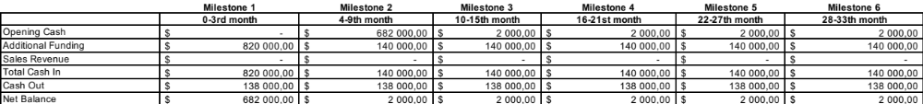

Financial Projections

Phase 1 – Milestone 1 (Months 0-3):
- Focus on product development, pilot deployments, and initial customer acquisition.
- Revenue streams will likely be limited to implementation and customization of the MVP.
- Costs will be dominated by personnel for R&D and cloud infrastructure.

Phase 2 – Milestones 2 & 3 (Months 4-15):
- Revenue streams will be diversified to include subscription revenues.
- Focus on market expansion, customer acquisition, and scaling operations.
- Sales & marketing costs will increase as the market reach expands.

Phase 3 – Milestones 4 to 6 (Months 16 – 33):
- Focus on market leadership, profitability, and potential new product lines.
- Subscription revenue is expected to reach a significant level.
- Costs will stabilize or grow at a slower rate as the product matures.

Revenue Streams
- Implementation & Customization Services: Offer professional services for data migration, system integration, and user onboarding (one-time fees) and develop custom features or integrations for specific customer needs (hourly or project-based fees) on top of the currently built MVP.
- Subscription Fees: Implement a tiered subscription model with varying feature sets and pricing options (Starter, Growth, Enterprise). Pricing will depend on factors like customer size, industry, and features required.

Cost Structure
- Research & Development (R&D): Ongoing costs associated with product development, maintenance, and innovation.
- Personnel: Salaries and benefits for employees in sales, marketing, engineering, customer support, and administration.
- Sales & Marketing: Costs of marketing campaigns, lead generation, attending industry events, and building brand awareness.
- Cloud Infrastructure: Costs associated with cloud platform hosting, data storage, and server maintenance.
- Professional Services: Costs associated with delivering implementation and customization services (if outsourced).

Funding Requirements:

Based on initial estimates, Ambient Systems will need to secure at least HK$820k to begin operations in Hong Kong by hiring two local personnel. It will require funding from the HKSTP incubator as well as additional R&D grants from the government, such as the RTH scheme.

These estimates are based only on operations in Hong Kong and do not include expenses or revenues generated from locations outside of Hong Kong. A separate financial plan will need to be developed for those locations.

Section 6: Services of HKSTP Incubation Programme

- Financial Support: Financial support from the HKSTP Incubation Programme is a crucial component in sustaining and scaling Ambient Systems. This assistance enables us to allocate resources strategically, invest in talent acquisition, and meet operational costs during the critical early stages of our development. The financial backing ensures that we can navigate challenges and focus on achieving key milestones without compromising on innovation.

- Business Development Support & Services: Business development support offered by HKSTP significantly contributes to Ambient Systems' growth. Through this support, we gain access to state-of-the-art facilities and a network of industry experts. This accelerates our R&D processes, facilitates testing and validation of our solutions, and ensures that our products remain at the forefront of technological advancements.

- Office Space: HKSTP's provision of office space is instrumental in providing Ambient Systems with a conducive environment for innovation and collaboration. The dedicated office space offers a professional setting for our team to focus on R&D activities, conduct meetings, and foster a culture of creativity. This infrastructure is vital for building a cohesive team and optimizing productivity.

- InnoCell Facilities: The availability of living facilities as part of the incubation programme adds a practical dimension to Ambient Systems’ operations. This offering is particularly beneficial for team members relocating or working across borders, ensuring a seamless transition, and facilitating their focus on critical tasks. Comfortable and convenient living arrangements contribute to a positive work-life balance, promoting overall well-being and sustained productivity.

- HKSTP Shenzhen Branch: The access to incubation facilities at the Shenzhen branch enhances Ambient Systems’ market reach and provides strategic advantages. Shenzhen is a hub for technology and innovation, offering opportunities for collaboration, partnerships, and market exploration. The presence of a satellite office in Shenzhen positions Ambient Systems at the crossroads of the vibrant tech ecosystem, fostering connections that are invaluable for growth.

In summary, the comprehensive support provided by the HKSTP Incubation Programme, encompassing office space, technology and business development assistance, financial support, a strategic Shenzhen office, and living facilities, collectively forms a robust framework for Ambient Systems’ growth. These services not only address immediate operational needs but also position our company strategically within the innovation ecosystem, fostering long-term succes

Appendix

Appendix A: Milestones

 | Milestone 1 | Milestone 2 | Milestone 3 | Milestone 4 | Milestone 5 | Milestone 6
 | 0 to 3 | 4 to 9 | 10 to 15 | 16 to 21 | 22 to 27 | 28 to 33
Start: July 2024 | September 2024 | January 2025 | June 2025 | January 2026 | June 2026 | January 2027
Product Development Progress
Design Work | Complete architecture diagrams, user flows (UX), and product design user interface (UI). | Identify user requirements for a pilot implementation based on customer interviews. | Identify requirements for a pilot implementation based on customer interviews. | Hardware design improvements consisting of multimodal sensing, miniaturization, sensor fusion, Low-Power Wide-Area Networks (LPWAN) adoption. | Hardware improvements for on-device AI implementation, alternative displays, and energy-efficient power supply. | Internationalization of product designs to different languages and regions, including China, Japan, and Europe.
Prototype / Demo | Complete MVP for dual-use case: deep tech (e.g., vertical farming, commercial real estate, transportation, and construction) and FinTech. | Create standard connections between Ambient Systems and main ERP systems. Demonstrate real-time IOT sensor integration. | Create API guide on how to connect Ambient Systems and established ERP, IoT, and telematics solutions for different use cases and clients. | Conduct field pilot study or studies with finance teams in construction, commercial real estate, and transportation companies in Hong Kong or GBA or SEA, demonstrating financial benefits of the comprehensive solution. | Full scale implementation with multiple pilot sites. | Expand functionality to new use cases in financial operations like audit and new industry verticals like banking, asset management, and insurance.
Launch | Identify additional usability and launch requirements for Hong Kong and GBA, aligning them with global markets. | Test the software MVP. | Conduct alpha testing with priority users. | Conduct beta testing with external users during on-field pilot. | Fix any hardware integration issues identified during testing. | Provide ongoing support and maintenance.
Business Development Progress
Activity - Number | 5 | 10 | 11 | 11 | 17 | 16
Activity - Details | Secure customers for subscription offering, complete Hong Kong market analysis, competitor mapping, and partnership discussions, validate product demand. | Strategic partnerships established, initial client engagements. | Client acquisition campaigns. | Intensive client acquisition, additional partnerships. | Optimize client relationships, explore new markets. | Global market entry, expanded partnerships.
Partners  (Co Name & supporting document) | HKSTP, Venture Capital Firms, Angel Investors | None | None | None | None | None
Clients - Number | 0 | 0 | 1 | 1 | 1 | 1
Clients – Details  (Please provide names) | Vertical Farming and Commercial Real Estate | Transportation and Construction | All Industries | All Industries | All Industries | All Industries
Sales Revenue
Core Product | $0 | $0 | HK$5,800 | HK$5,800 | HK$5,800 | HK$5,800
Non-Core product | $0 | $0 | $0 | $0 | $0 | $0
Corporate Development Progress
Awards - Number | 0 | 1 | 1 | 1 | 0 | 0
Awards - Details | None | Standard #1 | Standard #2 | Standard #3 | None | None
Head Count - FT (Non- Tech) | 0 | 0 | 0 | 0 | 0 | 0
Head Count - FT (Tech) | 2 | 2 | 2 | 2 | 2 | 2
Head Count - FT (Tech) | - R&D Lead (Founder)  - Software Developer | - R&D Lead (Founder)  - Software Developer | - R&D Lead (Founder)  - Software Developer | - R&D Lead (Founder)  - Software Developer | - R&D Lead (Founder)  - Software Developer | - R&D Lead (Founder)  - Software Developer
Head Count - PT | 0 | 0 | 0 | 1 | 1 | 0
Head Count - PT | None | None | None | None | None | None
I.P. Application - Patent - Number | 0 | 0 | 0 | 0 | 0 | 0
I.P. Application - Patent - Details | None | None | None | None | None | None
I.P. Application - Trademark - Number | 0 | 1 | 2 | 2 | 1 | 1
I.P. Application - Trademark - Details | None | Hong Kong | Singapore and Canada | China and Japan | United States | EU
I.P. Application - Other filings - Number | 0 | 0 | 0 | 0 | 0 | 0
I.P. Application - Other filings - Details | None | None | None | None | None | None

Appendix B: Company Overview and Strategic Evolution

Incorporated by Ivan Damnjanović and Ivan Damnjanovic in Singapore on July 5, 2021.

History and Milestones

Ambient Systems commenced its operations with a specific focus on addressing challenges in vertical farming, leveraging innovative technologies. This initial phase led to a strategic partnership with the National University of Singapore, resulting in a recognized patent by the World Intellectual Property Organization (WIPO) in 2022. The company's success in vertical farming laid the foundation for expansion into commercial real estate. During this phase, Ambient Systems not only gained international acclaim but also developed valuable intellectual property, showcasing its versatility and adaptability.

Strategic Pivot to Fintech

As the company delved into the intricacies of financial management within agriculture and real estate sectors, a broader realization emerged—a unique opportunity to revolutionize financial planning and management (FP&M) on a larger scale. This marked a strategic pivot for Ambient Systems, repositioning itself as a fintech innovator.

The transition into the fintech landscape aligns with the company's commitment to providing comprehensive solutions for diverse financial challenges. At the core of this strategic shift is the development of a cloud-based Financial Planning and Management Software (FP&M SW), integrating cutting-edge technologies such as AI and IoT. This evolution represents Ambient Systems' ambition to pioneer advancements in FP&M technology with a global perspective.

Current Objectives: Investments and Customer Onboarding

Ambient Systems is currently focused on two strategic objectives:
- Securing Strategic Investments: Actively seeking strategic investments to propel ongoing R&D initiatives, enhance the technology stack, and expedite market penetration.
- Onboarding Initial Customers: Dedicated to showcasing the tangible value of its FP&M SW by onboarding initial customers across diverse industries.

Key Achievements

The success of Ambient Systems is highlighted by several notable achievements:
- Emerging as the Panasonic Deep Tech Innovation Challenge Winner.
- Participation as a Startup Exhibitor at the inaugural City.Tech-Tokyo in 2023.
- Founder Ivan Damnjanović́ joining Antler Singapore Cohort 13, emphasizing the commitment to talent and innovation.
- International acclaim with a patent recognized by WIPO in 2022.
- Achieving First Runner-up in the Google Cloud Hackathon in Singapore in 2022.

Appendix C: Customer Problems

This section describes the individual customer needs identified from Section 1: Products & Solutions to Be Developed. These pain points are tailored for the use case in Transportation. However, similar pain points are faced by finance teams in other industry verticals where we previously conducted interviews. These include professional services, financial services, and pharmaceutical industries. Some of the details in new solution column will be unique to the operations of a transportation business. For example, data from cameras on vehicles can be used for certain finance-oriented goals. These hardware components, such as sensors, may be less critical for other use cases.

These problem domains are listed here and elaborated further in the following pages.

- Forecast revenues and expenses
- Long-term funding and investments
- Paying and managing taxes
- Cost control
- Managing cash flow and revenues
- Managing risks
- Ensuring compliance

 | List of Problems | Today’s Solution | New Solution
1 | Finance team needs to forecast revenues/expenses | The finance team gathers historical financial data (past revenues, expenses, etc.) and input from other teams. The financial data may be segmented for different revenue streams (e.g. group bookings, individual bookings, etc). The finance team analyses the market for external factors (travel demand, economic conditions (fuel process, GDP growth, etc), seasonality and demand trends (tourism, holidays, events, demographic changes, etc), competition, etc). The finance team breaks down the various cost components (fuel, insurance, labour, maintenance, marketing, overhead, inflation, etc). The data is consolidated into a spreadsheet with hardcoded formulas to generate a forecast. Forecasts may be generated for best-case/worst-case/moderate-case scenarios. Finance team updates forecast using actual data. | Cloud-based FP&M SW that can consolidate financial and operational data from multiple databases to analyze using AI and generate accurate forecasts for revenue and expenses, and provide recommendations based on the data. Leading to better decision making and profitability, etc.  Additional IoT and camera with data collection system may be employed to generate and utilize new and important information (e.g. passenger profiles, trip information, etc) for more accurate forecasting.
2 | Finance team needs to seek long-term funding and make investments | Finance team considers the long-term financial goals and objectives. They identify potential investment opportunities based on the strategic goals (e.g. acquire new buses, expand routes, upgrade systems, improve customer experience, etc.). They perform risk assessment associated with the investment (e.g. market uncertainties, regulatory changes, operational changes, etc.). Diversification may be used to mitigate risks. They perform cost-benefit analysis for each investment to determine if financially viable. They consider the financing options (e.g. internal funds, bank loans, issuing bonds, seeking investors, etc.). They calculate the ROI to determine if risk is justified. They monitor the performance to identify required improvements and corrective actions. They communicate with stakeholders about discussions and strategies. | Cloud-based FP&M SW that can budget for investment and quantify risks of investment opportunities based on financial and other data and project how to reach desired financial goals. Leading to improved decision making and profitability, etc.
3 | Finance team needs to pay/manage taxes | Finance team identifies applicable taxes (e.g. income, sales, payroll, carbon, etc) and stays informed about updates. They also identify tax deduction/credits (e.g. fuel costs, maintenance, depreciation, etc). They perform tax planning to minimize tax liability within legal requirements. They consolidate financial data and input from other teams to keep accurate data. They determine based on tax formulas (or tax compliance SW) the amounts to be paid and generate reports. They file taxes and issue payments according to the required timeline. They maintain documentation for auditing. | Cloud-based FP&M SW that can consolidate financial and operational data from multiple databases to analyze using AI and generate recommendations for tax deductions and tax amounts based on tax policies/formulas provided.
4 | Finance team needs to implement cost-control | Finance team consolidates historical financial data and budget from other teams. They identify possible costs to be reduced. They consider ways to reduce the cost (market research, alternatives, consultation, feedback). They initiate/purchase new cost-control initiatives. They evaluate impact of cost-control implementations. | Cloud-based FP&M SW that can consolidate financial and operational data from multiple databases to analyze using AI and generate recommendations for reduced costs based on constraints and operations. (E.g. reducing maintenance, insurance, fuel, delay). Expected impact of changes can the quantified.  Additional IoT and camera with data collection system may be employed to generate and utilize new and important information (e.g. driving behaviour, road condition, etc) in order to provide actionable recommendations.
5 | Finance team needs to manage cash flow | Finance team gathers financial data and budget from other teams. With the help of SW, they forecast the inflows and outflows over specified periods (e.g. quarterly) and determine potential cash shortage/surplus. They monitor and follow up on accounts receivable and accounts payable. They negotiate favourable terms with customers and suppliers. They send invoices to customers and follow up on overdue payments disputes. They approve expenses and avoid unneeded expenses. They establish credit limits and monitors credit terms. They may arrange short-term financing. They maintain the capital balance (assets vs liabilities) and liquidity. They ensure sufficient cash reserves. They manage debts and loans. They implement changes as required to sustain operations and growth. | Cloud-based FP&M SW that can consolidate financial data from multiple databases to analyze using AI and generate recommendations for sustaining effective cash flow and growth.
6 | Finance team needs to manage risks | Finance teams identifies various possible risks (e.g. operational, financial, regulatory market, reputational, etc) and determines impact and likelihood. They develop strategies to mitigate or minimize risks (e.g. preventive measures, contingency plans, response protocols, redundancy/alternative supply). They ensure sufficient insurance coverage (e.g. accidents, liability, property damage, etc). They may use financial instruments like hedging. They negotiate contractual terms with suppliers/customers to reduce risks. They keep up and comply with regulations to reduce risks. The have internal controls to prevent errors/fraud/mismanagement/etc. | Cloud-based FP&M SW that can consolidate financial data from multiple databases to analyze using AI and inform of potential risks to the company and deviations to forecasts.
7 | Finance team needs to ensure compliance | Finance team determines relevant regulations. They impose control to ensure compliance and necessary processes to support auditing. | Cloud-based FP&M SW that can consolidate financial data from multiple databases to verify datasets and identify potential anomalies in the data.  Additional IoT and camera with data collection system may be employed to check operational data for compliance (e.g. driving behaviour, bus operations)

Appendix D: Product Demo

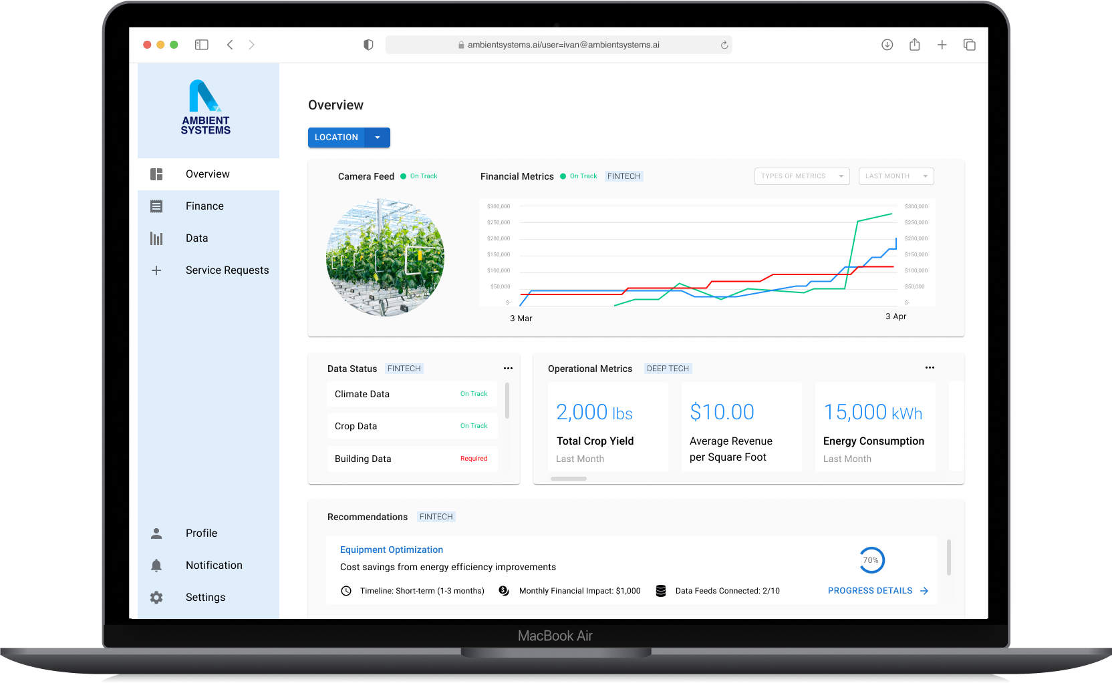

Demo recording vide: https://www.youtube.com/watch?v=nP0qbw6CsJY&ab_channel=AmbientSystems

Appendix E: Technical Implementation Details

R&D Stream #1: Web Application Tech Stack with Current State & Future State Analysis
Tech Category | Current State | Future Considerations | Technical Complexity
Frontend Technologies | The React library, along with react-dom, is currently utilized for building UI components and rendering them in the DOM. | Explore latest React features; Adopt React concurrent mode. Optimize rendering for improved performance and user experience. | Moderate, adaptation to new features; testing for compatibility.
Frontend Technologies | Material-UI is employed for its core components (@mui/material), icons (@mui/icons-material), and utilizes @mui/styled-engine-sc for styling | Explore additional icon libraries; Optimize for icon usage. Stay updated with Material-UI releases; Optimize component usage. Consider alternative styling solutions; Optimize for performance. | Moderate, library exploration and integration. Moderate, staying aligned with Material-UI updates. Moderate, evaluating and implementing alternative solutions.
Frontend Technologies | PrimeReact is utilized for its UI components (primereact) and icons (primeicons). | Explore additional icon libraries; Optimize for icon usage. Stay updated with PrimeReact releases; Optimize component usage. | Moderate, library exploration and integration. Moderate, staying aligned with PrimeReact updates.
Styling Technologies | The Emotion library (@emotion/react) is used for styling React components, and styled components are created using @emotion/styled. | Explore new features in Emotion; Optimize for performance. Consider alternative styling solutions; Optimize for performance. | Moderate, adaptation to new features; testing for compatibility. Moderate, evaluating and implementing alternative solutions.
Styling Technologies | Styled-Components is employed as a library for writing CSS within JavaScript using components. | Stay updated with Styled-Components releases; Optimize styling approaches. | Moderate, staying aligned with Styled-Components updates.
Data Visualization and Charting | Recharts, a library for creating interactive and customizable charts in React applications, is currently used for data visualization. | Explore additional charting libraries; Optimize for performance. | Moderate, library exploration and integration.
Utility Libraries | The axios library, a promise-based HTTP client, is currently in use for making API requests. | Optimize API request handling; Explore alternatives for specific use cases. | Moderate, performance optimization; evaluating alternatives.
Utility Libraries | dayjs, a library for date and time manipulation, is currently utilized for handling date-related functionalities. | Explore new features in dayjs; Optimize for performance. | Moderate, adaptation to new features; testing for compatibility.
Utility Libraries | Firebase services and features are currently employed for various backend functionalities in the application. | Explore new Firebase features; Optimize for performance. | Moderate, adaptation to new features; testing for compatibility.

R&D Stream #2: System Architecture (Cloud Computing) with Current State & Future State
Tech Category | Current State | Future Considerations | Technical Complexity
Cloud Service Provider | Current infrastructure is hosted on GCP, leveraging its advanced machine learning capabilities and services | Considering AWS for its extensive range of services and compatibility with China; exploring OVH Cloud for European presence; Tencent Cloud for access to the Chinese market. | Migrating infrastructure, ensuring data consistency, and optimizing performance in the new cloud environment.
Compute Resources & Scaling | Reliance on Google Compute Engine for virtual machine instances. | Exploring alternatives such as AWS EC2, OVH Compute, and Tencent Cloud VM for efficient and scalable compute resources. | Efficiently provisioning and scaling compute resources based on demand while minimizing costs and optimizing performance.
Serverless Computing | Serverless computing is implemented using Google Cloud Functions. | Exploring AWS Lambda and Tencent Cloud Serverless for efficient serverless computing. | Adapting applications to serverless architectures, optimizing function execution, and ensuring proper scaling.
Data Storage | Current data storage solutions are implemented using Google Cloud Storage. | Considering AWS S3, OVH Object Storage, and Tencent Cloud Storage for optimized data storage solutions. | Migrating existing data, ensuring data integrity, and optimizing storage costs in the new storage environment.
Database Services | Relational databases are managed using Google Cloud SQL. | Exploring AWS RDS, OVH Database, and Tencent Database as managed database service alternatives. | Ensuring seamless migration of databases, optimizing performance, and adapting applications to the new database services.
API Integration | Robust API integration capabilities are achieved using Google Cloud Endpoints/API Manager. | Planning to build easy-to-use standard connectors to enhance API integration capabilities. | Designing connectors that are modular, adaptable, and ensuring compatibility with diverse systems.
Monitoring and Logging | Current monitoring and logging solutions are based on Google Cloud Monitoring. | Considering AWS CloudWatch, Tencent Cloud Monitor, and potentially continuing with Google Cloud Monitoring. | Adapting existing monitoring and logging configurations, ensuring seamless transition, and maintaining visibility into system health.

Cloud Architecture Diagrams

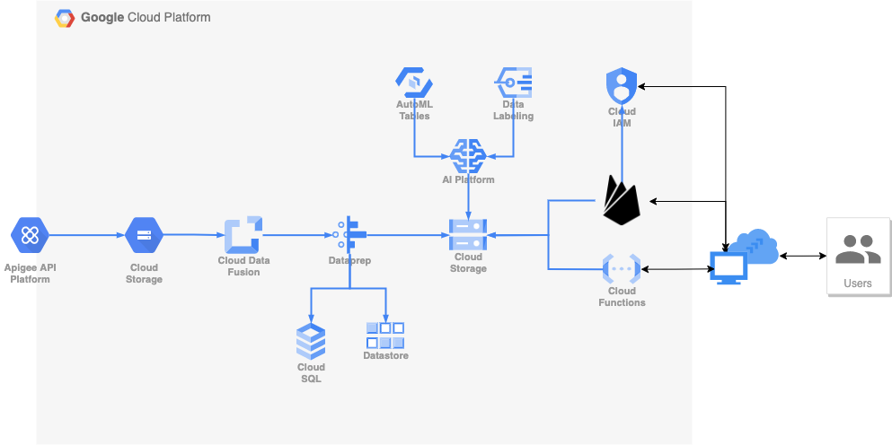
Current state (GCP Native)

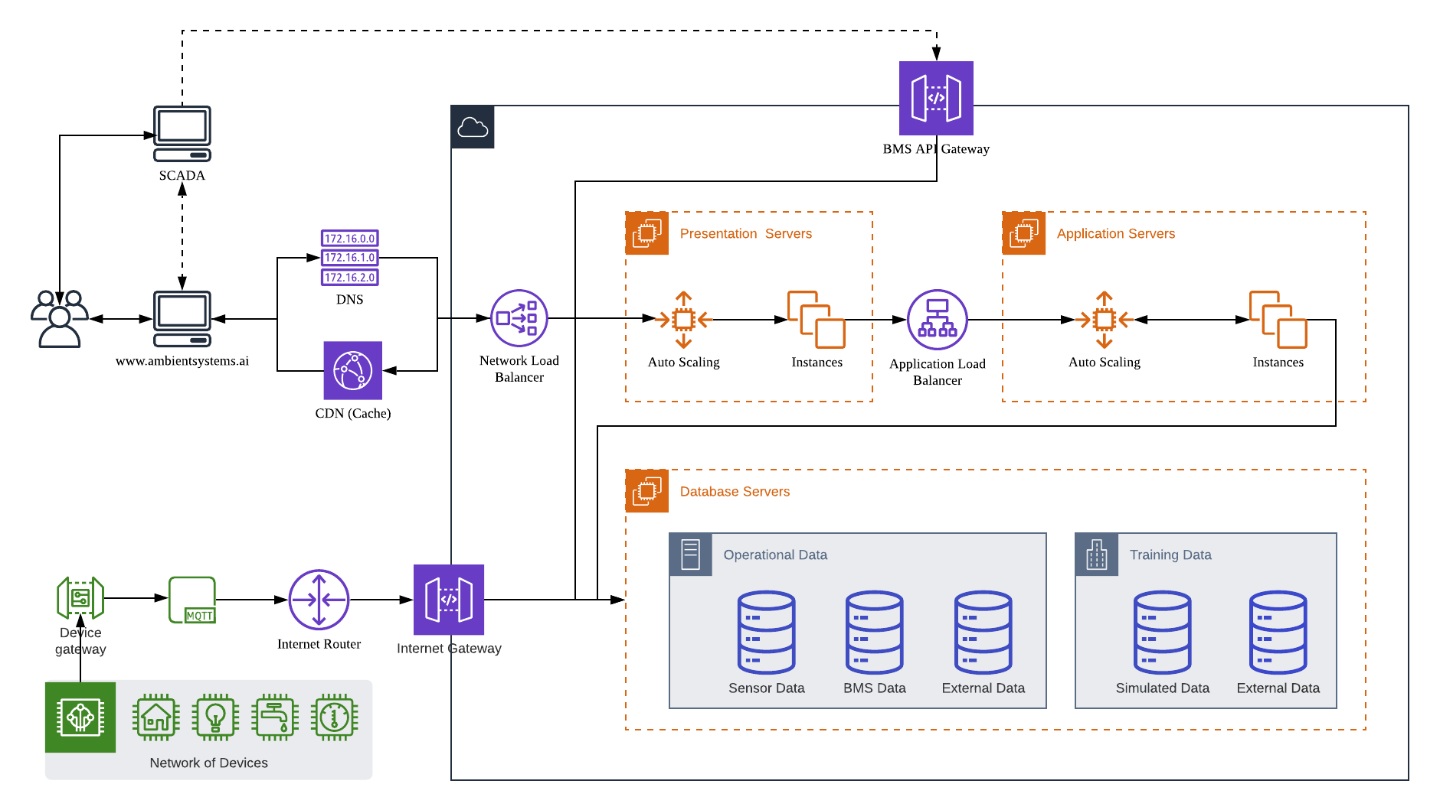
Current State (AWS Cloud Architecture with IoT Network)

Further to the technology stack, Ambient Systems has secured a patent in vertical farming. The architecture of the patent follows the following diagram. More information can be found through WIPO patent filing.

R&D Stream #3: Machine Learning / AI Technology with Current State & Future State
Tech Category | Current State | Future Considerations | Technical Complexity
ML Framework | Utilizing an in-house ML framework or library (e.g., TensorFlow, PyTorch, Scikit-learn). | Exploring alternative frameworks for improved performance, compatibility, and additional features. | High: Assessing framework compatibility, migration efforts, and performance optimization.
Model Deployment | Deploying models using a serverless architecture using Vertex AI. | Exploring cloud-based deployment options such as AWS SageMaker, Google AI Platform, and Tencent ML Platform. | High: Adapting deployment pipelines, ensuring scalability, and optimizing inference speed.
Data Preparation | Utilizing in-house scripts and tools for data preprocessing. | Evaluating tools like Apache Spark, AWS Glue, and Tencent Cloud DataWorks for scalable and efficient data preparation. | Integrating new tools into existing workflows, ensuring data consistency, and optimizing preprocessing tasks.
Model Development | Utilizing an in-house ML framework or library (e.g., TensorFlow, PyTorch, Scikit-learn).  Deploying models on a dedicated server using Flask and Docker. | Exploring alternative frameworks for improved performance, compatibility, and additional features.  Exploring cloud-based deployment options such as AWS SageMaker, Google AI Platform, and Tencent ML Platform. | Assessing framework compatibility, migration efforts, and performance optimization.  Adapting deployment pipelines, ensuring scalability, and optimizing inference speed.
Model Training | Training models on local GPU servers with custom scripts.  Manual hyperparameter tuning using in-house scripts. | Exploring cloud-based training services like AWS SageMaker, Google AI Platform, and Tencent ML Platform.  Investigating automated tuning solutions like AWS Hyperparameter Optimization and Google AI Platform [Third party]. | Adapting training workflows, optimizing for distributed training, and managing costs.  Integrating automated tuning into existing workflows, optimizing for diverse models, and monitoring tuning performance.
[Third party] | Manual hyperparameter tuning using in-house scripts. | Investigating automated tuning solutions like AWS Hyperparameter Optimization and Google AI Platform [Third party]. | Integrating automated tuning into existing workflows, optimizing for diverse models, and monitoring tuning performance.
Model Evaluation | Employing custom evaluation metrics in post-training analysis.  Limited version control with manual tagging. | Considering cloud-based evaluation tools such as AWS Model Evaluation, Google AI Platform Evaluation, and Tencent ML Evaluation.  Exploring versioning solutions like DVC, MLflow, and Git-LFS for more structured model versioning. | Integrating new evaluation tools, ensuring consistency in metrics, and adapting analysis workflows.  Implementing version control processes, ensuring traceability, and adapting collaboration workflows.
Output | Currently printing results to the output monitor or text file. | Planning to create an output pipeline connection to various sources and formats.

R&D Stream #4: IoT Hardware Technology with Current State & Future State
Tech Category | Current State | Future Considerations | Technical Complexity
Sensing Device | - Firebeetle 32 ESP32: Microcontroller for data acquisition and pre-processing (edge computing).  - Battery ([Third party]-ion 9000mAh): Long-lasting power source for remote deployments.  - Temp, Humi, CO2 sensor (Senserion SCD30): Environmental sensor gathering key data points.  - Light Sensor (BH1750): Additional sensor for contextual data. | - Multimodal Sensing: additional sensors like soil moisture, air pressure, or audio for richer data collection.  - Microcontroller Miniaturization: Smaller, more energy-efficient microcontrollers and sensors for compact deployments.  - Sensor Fusion: Combine data from multiple sensors for enriched insights. | Moderate – Requires knowledge of programming & electronics for customization.  Potential challenges include sensor calibration & accuracy maintenance, and data acquisition optimization for resource-constrained devices.
Connectivity | 4G Router: Provides internet access for cloud communication and data transmission. | - Low-Power Wide-Area Networks (LPWAN): Long-range data transmission for remote locations.  - Satellite communication: Global reach beyond cellular network coverage. | Moderate – Requires knowledge of network protocols & security configurations.  Potential challenges include: ensuring reliable & secure data transmission in diverse environments and power optimization for extended connectivity in disconnected areas.
Processing Unit | Raspberry Pi 400: Handles complex data analysis, decision-making, and user interface. | - On-device AI implementation: Real-time data analysis & intelligent actions without relying solely on cloud.  - Edge computing capabilities: Enhanced processing power & reduced reliance on cloud infrastructure. | High – Requires expertise in programming, data analysis, & AI implementation.  Potential challenges include resource management & processing optimization for resource-constrained devices and balancing cloud dependence with on-device AI capabilities.
Display | Computer Display: Visualizes data and insights for user interactions. | - Alternative display configurations: Consider touchscreens, e-paper displays, or even voice outputs.  - Dynamic data visualization: Adapt visualizations based on user preferences & context. | Moderate – Requires knowledge of display technologies & user interfaces.  Potential challenges include ensuring user-friendly & informative data visualization across different display options and optimizing power consumption for extended display operation.
Input | Wireless Mouse: Allows user interaction with the system.  Rasberry Pi 400 keyboard | * Alternative input configurations: Explore touch controls, voice commands, or gesture recognition. * User experience optimization: Adapt input methods based on application & user preferences. | Moderate – Requires knowledge of input technologies & user interfaces.  Potential challenges include designing intuitive & accessible input methods for diverse users & environments and balancing flexibility with power efficiency and security considerations.
Power | Power adaptor (For Rpi, 5v, 3A): Powers the Raspberry Pi.  Battery storage for sensing devices. | Energy efficient power supply to be explored. | Moderate – Requires understanding of power electronics & energy management strategies. * Ensuring reliable & sustainable power supply for long-term deployments. * Balancing power consumption with system functionality & performance.

Appendix F: Market Segments

Phase 1 (Year 1 to Year 3)
Segment | Industry Vertical | Location | Accounts | Leads
Hong Kong Finance Team | Transportation (excluding aviation and maritime) | GBA: Hong Kong | 202 | 462
Hong Kong Commercial Real Estate | Commercial Real Estate | GBA: Hong Kong | 186 | 144
Finance Team | Financial Services, Insurance, & Investments | GBA: Hong Kong | 32 | 8k+
GBA – Real Estate | Commercial Real Estate | GBA: Shenzhen, Guangzhou, Macau, Zhuhai, Foshan Zhongshan, Dongguan, Huizhou | 229 | TBD
GBA - Transportation | Transportation (excluding aviation and maritime) |  | 455 | TBD
Management Teams | Vertical Farming | Global | 32 | 367
Total Accounts Phase 1 |  |  | 1.1k
Phase 2 (Year 4 to Year 6)
Segment | Industry Vertical | Location | Accounts | Leads
Finance Teams | Commercial Real Estate | Japan | 162 | TBD
All Teams | Transportation | Japan | 136 | TBD
Finance Teams and Sustainability Teams | Commercial Real Estate | Singapore/Southeast Asia | 13 | 610
Finance Teams | Transportation | Singapore/Southeast Asia | 16 | 164
Finance Teams | Commercial Real Estate | Canada | 2.5k+ | TBD
Finance Teams | Construction | Canada | 6k+ | TBD
Finance Teams | Transportation | Canada | 2k+ | TBD
Total Accounts Phase 2 |  |  | 11k
Phase 3 (Year 7 to Year 8)
Segment | Industry Vertical | Location | Accounts | Leads
Finance Teams | Transportation | US | 17k+ | TBD
Finance Teams | Transportation | UK | 3k+ | TBD
Finance Teams | Transportation | Europe | 17k+ | TBD
Total Accounts Phase 3 |  |  | 37k

Appendix G: Competitive Landscape

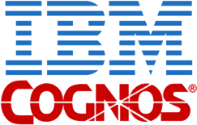







Finance Teams can Work Independently
Streamlined Data Integration
Limited Data Integration
Finance Teams Rely on Technology Experts
Ambient Systems provides businesses with streamlined data integration and faster financial planning through the use of AI.

